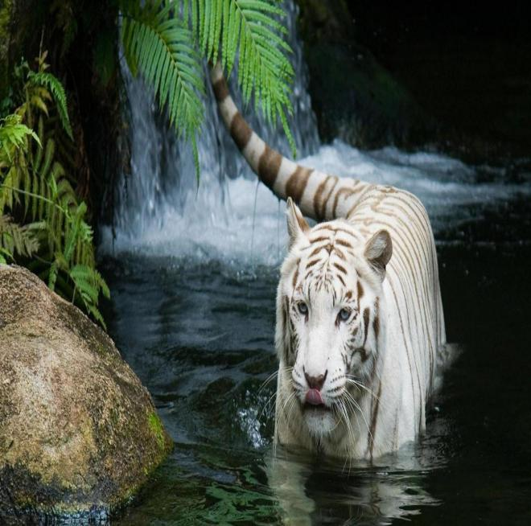

**Group Member**

* **Hafsa Hafeez**

**Id:788-20-10000129**

* **MIsbah Swaleheen**

**Id:788-20-10000126**

* **Maryam Hafeez**

**Id:788-20-10000127**

CENTRAL ZOO

Central Zoo Bringing Wild Into Your Home We’re here Together Stay Connected With The Animals

**Course Name**

**Web Designing And Web Engineering**



**0331-210-4418**



**Hafsahafeez28@gmail.com**

Central Zoo is committed to saving worldwide by uniting our expertise in animal care and conservation science with our dedication to inspiring for nature

**Acknowledgement**

**S**

**pecial thanks To Sir Mazhar Karimi for his guidance and his support.**

**He helped throughout the project. We thank our group members for their contribution and cooperating for making this project.**

**This project was made from the support and contribution of our group members. So we wish to thank you each one of us.**

**PS: If we forgot to thank anyone please forgive us, we are thankful to you too**

**Table of Content**

**Certification of Completion………………………………………..2**

**Acknowledgement……………………………………………………..3**

**Table of Content………………………………………………………..4**

**Introduction……………………………………………………………….6**

**Existing Scenario………………………………………………………..7**

**Proposed Solution……………………………………………………..9**

**Customer Requirement specification…………….………..14**

**Introduction**

The thirst for learning, upgrading technical skills and applying the concepts in real life environment at a fast pace is what the industry demands from IT professionals today.

However busy work schedules, far-flung locations, unavailability of convenient time-slots pose as major barriers when it comes to applying the concepts into realism. And hence the need to look out for alternative means of implementation in the form of laddered approach.

 The above truly pose as constraints especially for our students too! With their busy schedules, it is indeed difficult for our students to keep up with the genuine and constant need for integrated application which can be seen live especially so in the field of IT education where technology can change on the spur of a moment. Well, technology does come to our rescue at such times!! Keeping the above in mind and in tune with our constant endeavor to use Technology in our training model, we at Aptech have thought of revolutionizing the way our students learn and implement the concepts using tools themselves by providing a live and synchronous project learning environment!

***So what is this project?***

Project is a step-by-step learning environment that closely simulates the classroom and Lab based learning environment into actual implementation. It is a project implementation at your fingertips!! An electronic, live juncture on the machine that allows you to

1. Practice step by step i.e. laddered approach.
2. Build a larger more robust application.
3. Usage of certain utilities in applications designed by user.
4. Single program to unified code leading to a complete application.
5. Learn implementation of concepts in a phased manner.
6. Enhance skills and add value.
7. Work on real life projects.
8. Give a real life scenario and help to create applications more complicated and useful.
9. Mentoring through email support.

**Objectives of the Project**

The Objective of this program is to give a sample project to work on real life projects. These applications help you build a larger more robust application

The objective is not to teach you JavaScript/Dreamweaver but to provide you with a real life scenario and help you create basic applications using the tools.

You can revise the chapters before you start with the project.

This project is meant for students who have completed the module of Dreamweaver. These programs should be done in the Lab sessions with assistance of the faculty if required.

It is very essential that a student has a clear understanding of the subject. Students should go through the project and solve the assignments as per requirements given.

**Hardware & Software Requirements**

**Hardware**

1. A minimum computer system that will help you access all the tools in the courses is a Pentium 166 or better
2. 64 Megabytes of RAM or better

**Software**

1. Notepad/HTML editor
2. Dreamweaver
3. IE 5.0/ Netscape 6.0

**Problem Statement**

CENTRAL zoo is one of the biggest zoo in the town. The land area of the zoo is 33 acres. CENTRAL zoo was established in the year 1980 with 10 acre land but lately it was modified and land area was also added in the year 2000. Proper residing space for all the type of animals has been made and maintains human security at high rate. Proper supply of food for all the animals is maintained and checked at regular intervals. You need to develop a website for the CENTRAL zoo which will provide the information about all the animals (like species, animal classification) which are kept and along with their image.

***Requirement Specification:***

The Web site is to be created based on the following requirements.

1. The Home Page should be created making use of Sections with a suitable logo
2. The look and feel of the project must be made user friendly and uniformity in the color combination must be maintained
3. About us, Contact Us (address and map) must be added.
4. Animal’s information can be added in the categorized like birds, animals, water animals, and so on.
5. Safari option is there for which dummy booking option can be added.
6. Gallery of animals and birds must be added in the website.
7. Timings of the zoo must be added.
8. Navigation of the project must be made smooth.
9. Events organized (Informative for audience and for the welfare of the animals) must be noted.
10. Feedback and query can be added in the website.

**Central Zoo**

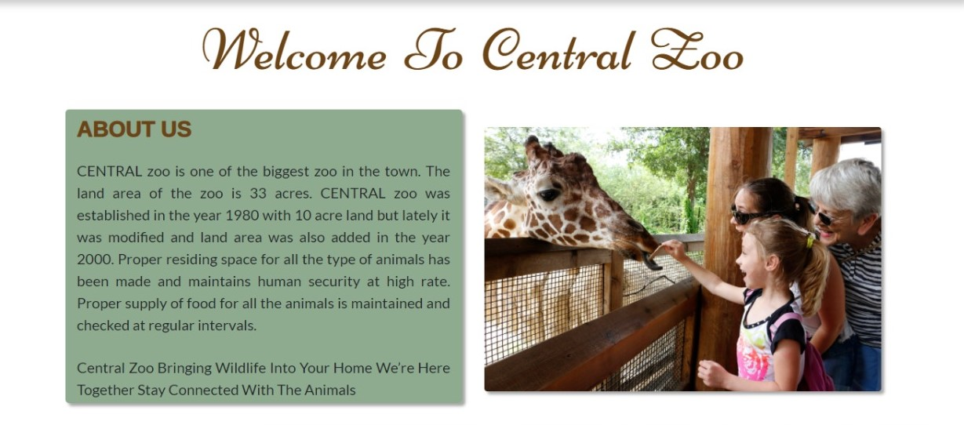

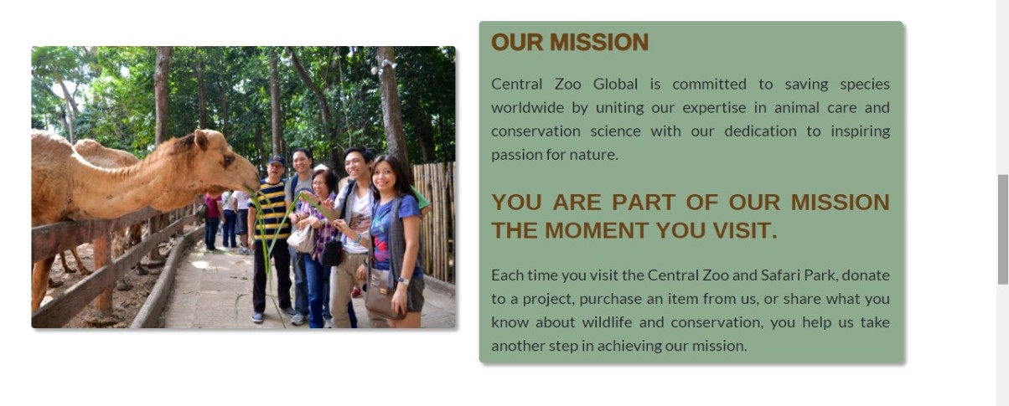

**Our Gallery**

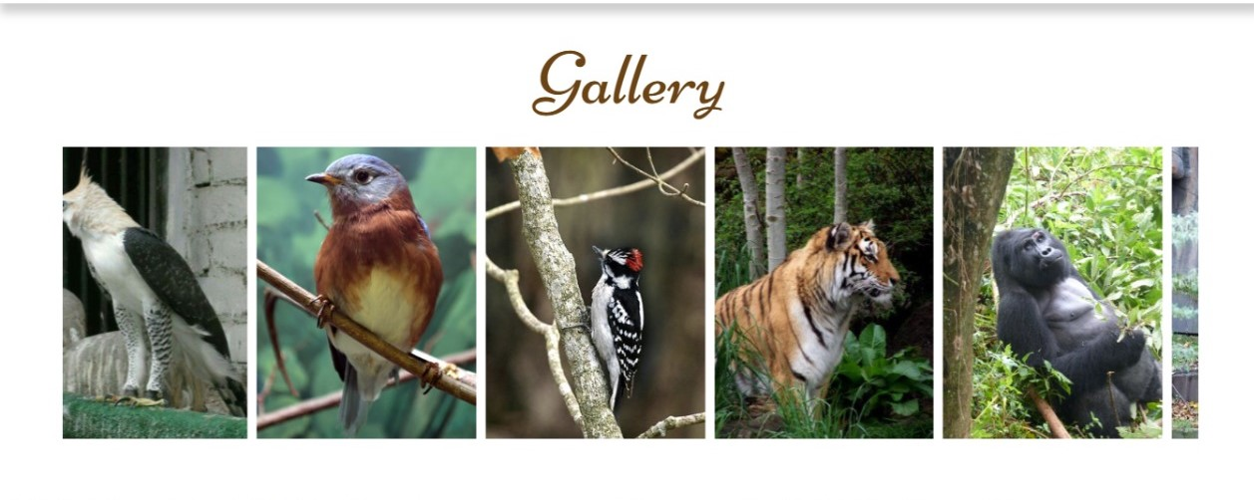

**Animal Gallery** is a sort of best-of, a carefully collected selection, over from our amazing categories: *Wild Animals, Birds* & *Fishes.* 3 titles filled with exuberant and extraordinary paintings of animals. Collective nouns some familiar, others wonderfully surprising are used to describe each group of animals

***Click on an image to view enlarged and in full***

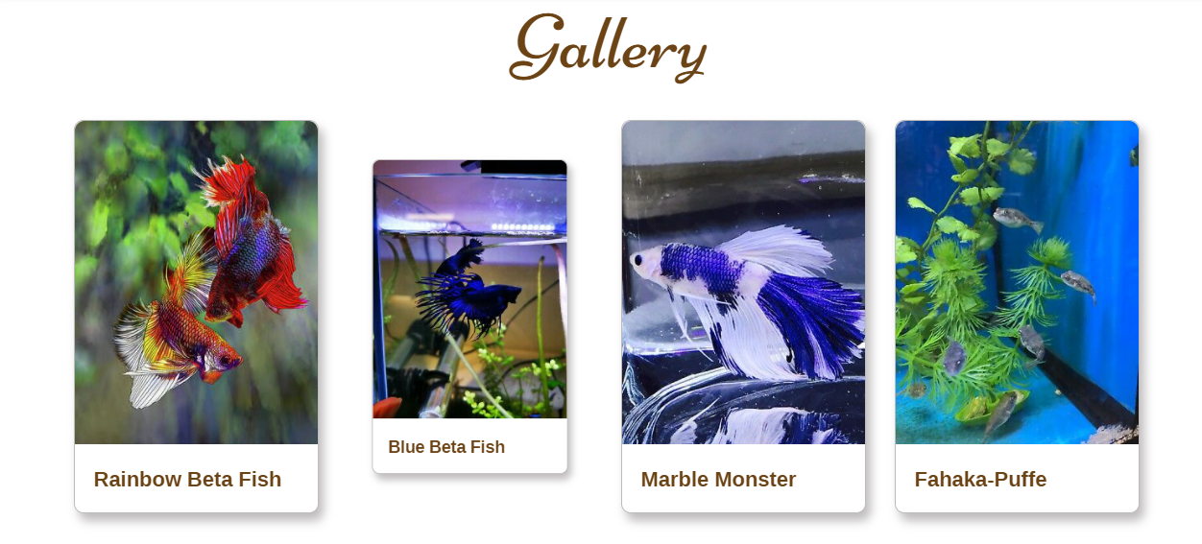

**Events**

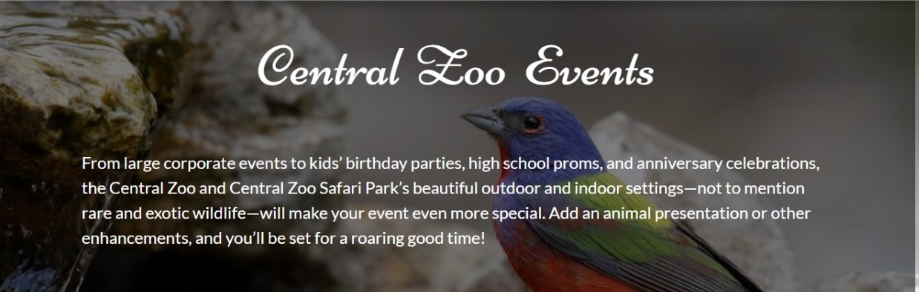

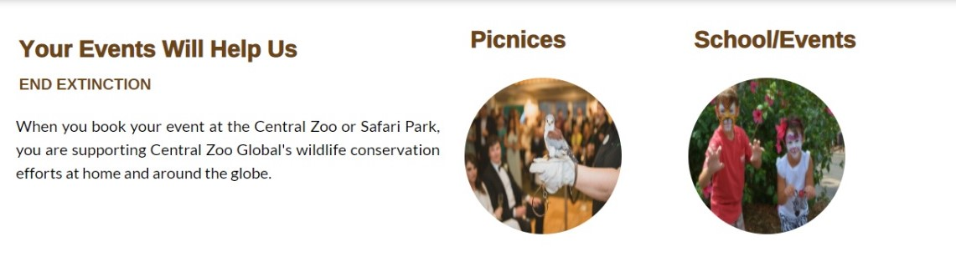

From large corporate events to kids’ birthday parties, high school proms, and anniversary celebrations, the Central Zoo and Central Zoo Safari Park’s beautiful outdoor and indoor settings—not to mention rare and exotic wildlife—will make your event even more special.

Add an animal presentation or other enhancements, and you’ll be set for a roaring good time! Large corporate events to kids’ birthday parties, high school proms, and anniversary celebrations, the Central Zoo and Central Roaring good time!

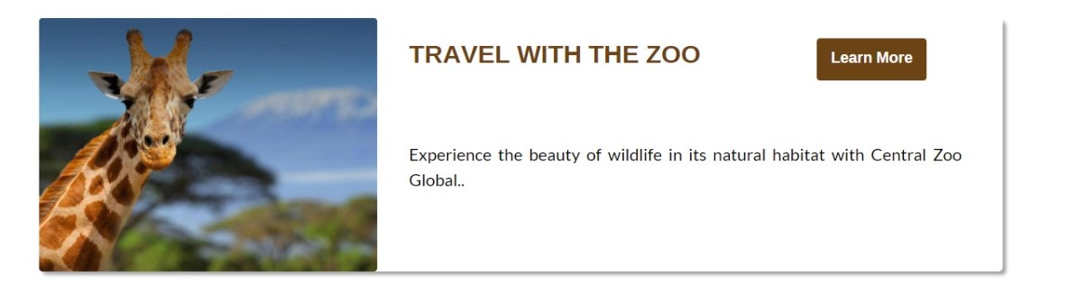

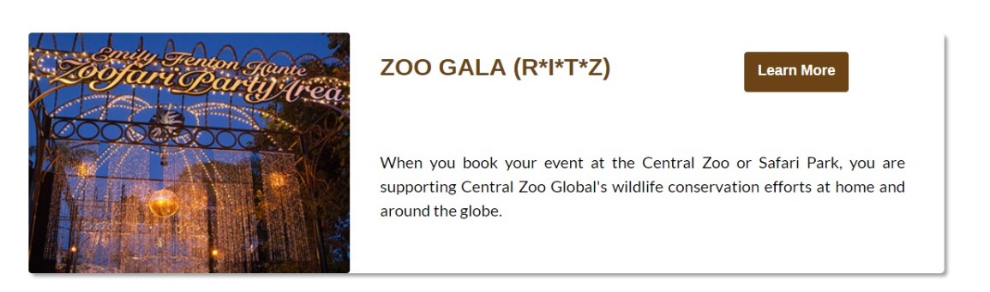

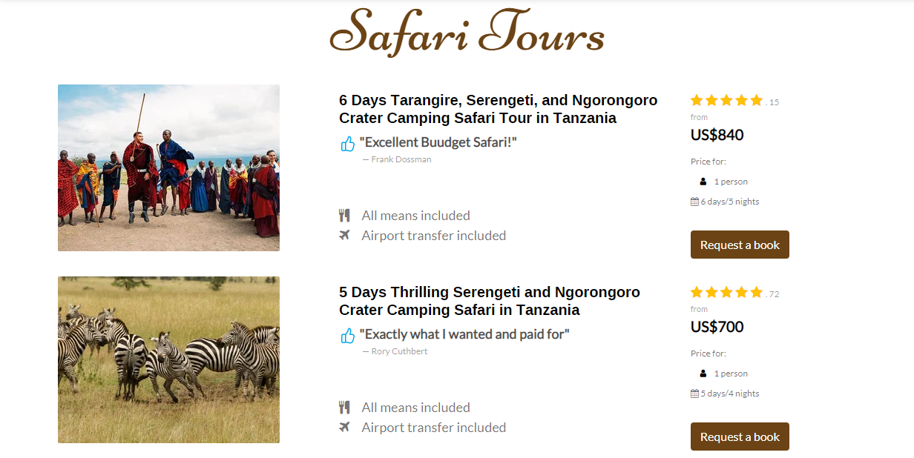

A **SAFARI**is an exciting and adventurous way of seeing the ‘real Africa’ because it enables you to view a variety of wildlife in their natural habitat. As a result, going on a safari gives you an authentic experience of Africa.

Safaris can involve walking through the wilderness, driving in 4×4 vehicles or by flying in light air craft. The**purpose of a safari tour** is to allow you to get intimate with the landscape and scenery.

While overland tours are mostly challenging, you need to be young at heart and open-minded to get the best out of an overland safari trip. All safari vehicles are custom-built to travel to remote parts of Africa often on long, bumpy roads, while allowing you to view wildlife from a safe distance in comfort.

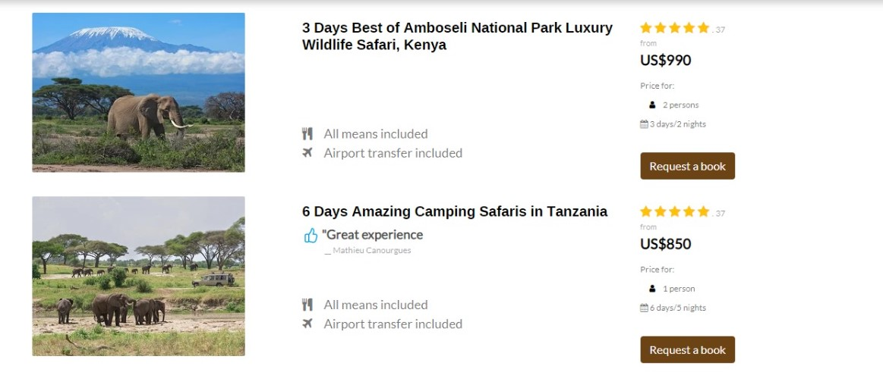

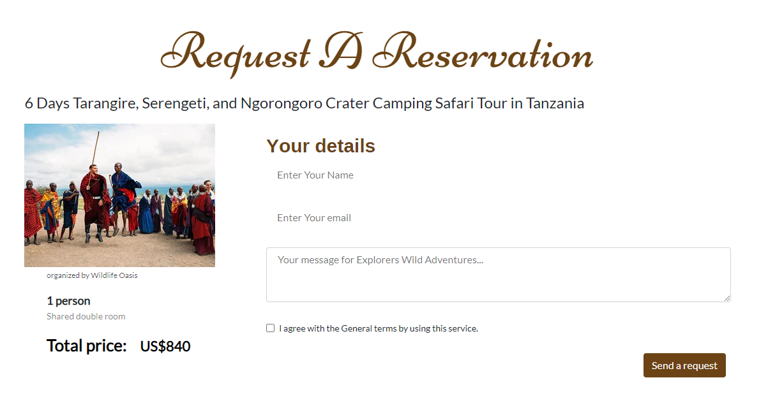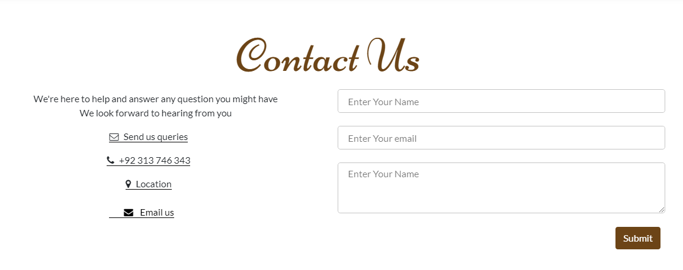

Contact us page is one of the most important pages on your website. For most companies, it's typically one of the most-visited site pages.

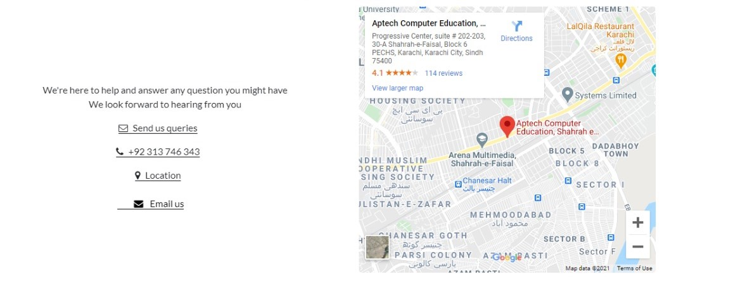

* **Are easy to find**so a visitor can quickly get in touch should they need it.
* **Explain why someone should contact them**, and describe how they can help solve their visitors' problems.
* **Include an email and phone number**so visitors can quickly find the right information.

**Forms**

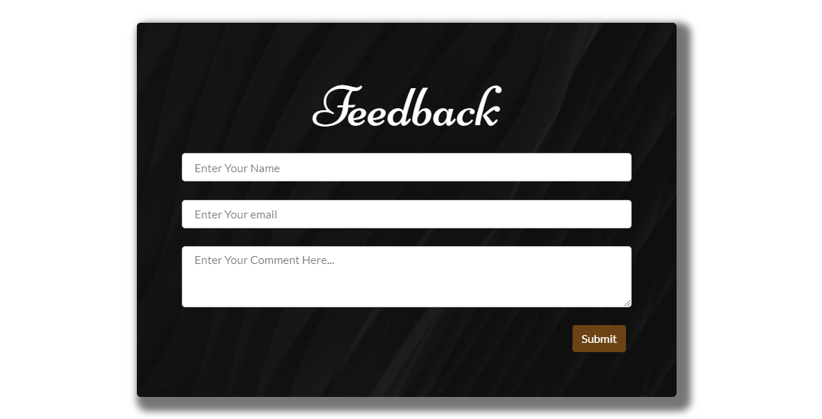

***Validation:***

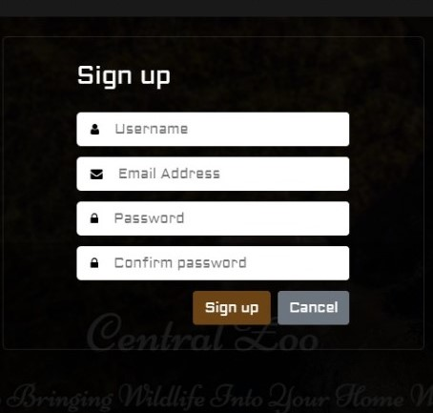 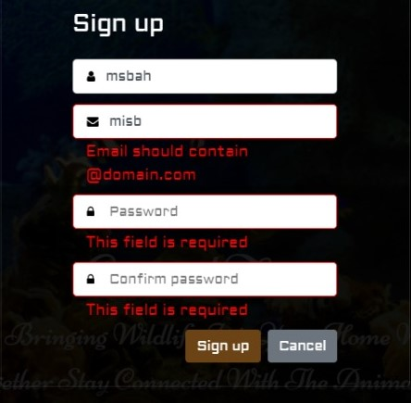

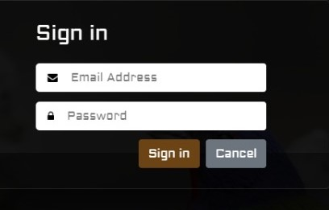 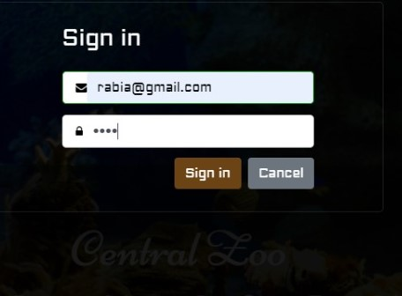

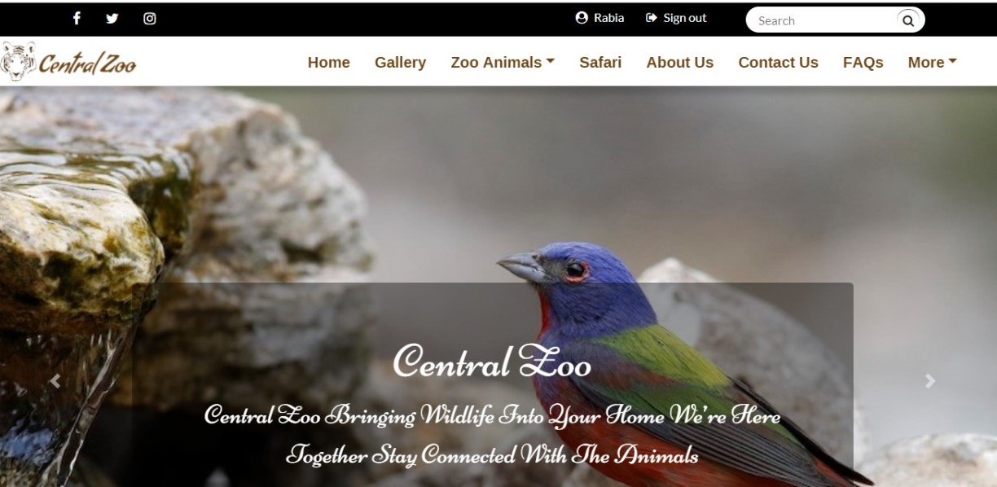

**Footer**

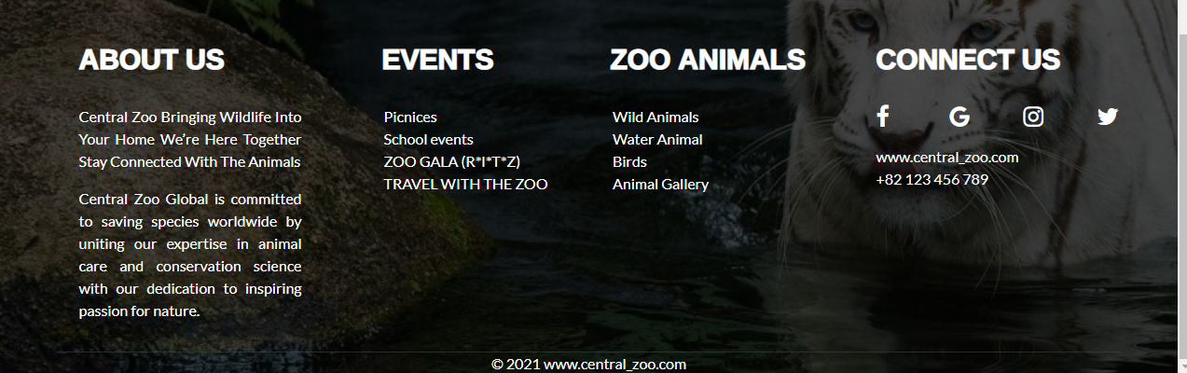

**Task Sheet**

|  |  |  |
| --- | --- | --- |
| **Assigned To** | **Task Division** | **Status** |
| Hafsa Hafeez | (Pages)  Home page  About us  Footer  Events  Documentation | Done |
| Misbah Swaleheen | Safari tours  Reservation form  Feedback  FAQs  Contact us  Sign in  Sign up  Search | Done |
| Maryam Hafeez | Gallery section  Wild animals  Water animals  Birds  Zoo time schedule | Done |

**THANK YOU**